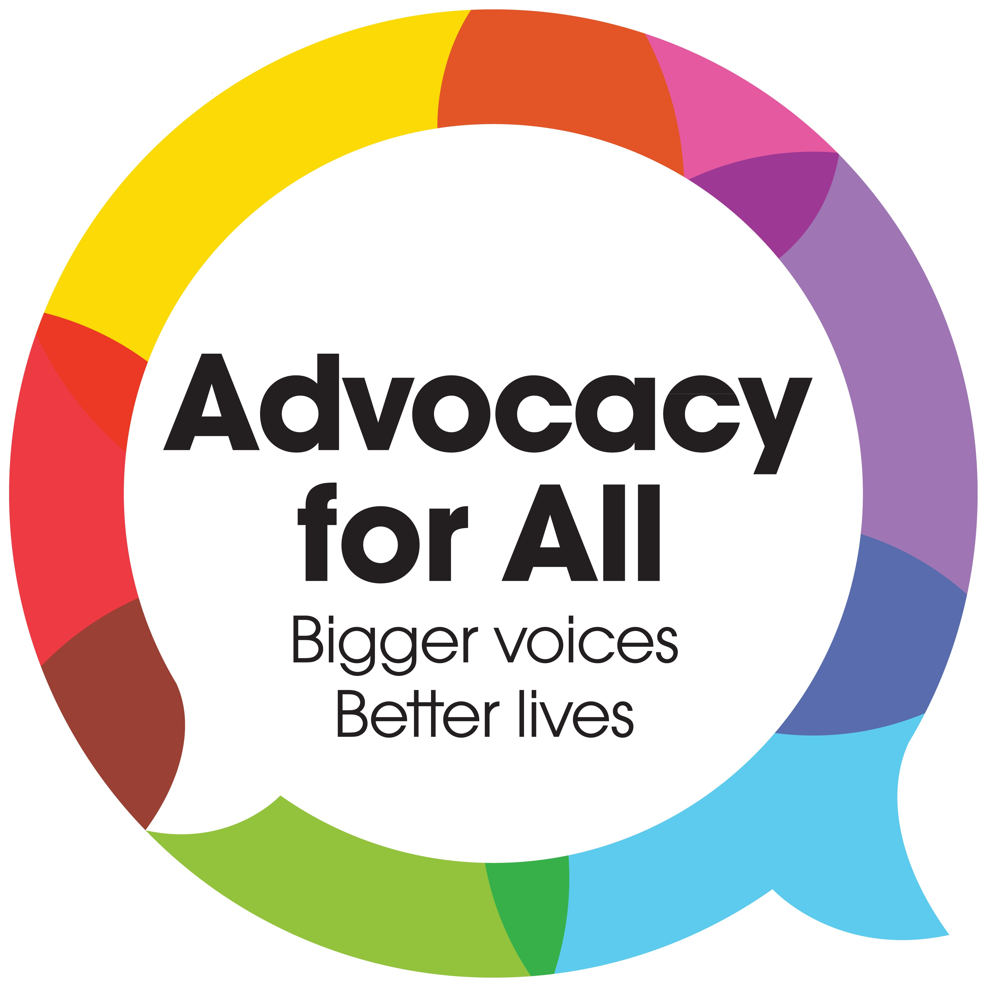

Care Act
Referral Form
Tel: 0345 310 1812

Email: referrals@advocacyforall.org.uk

Web: www.advocacyforall.org.uk

Advocacy for All
The Civic Centre
St Mary’s Road
Swanley
BR8 7BU

If you cannot complete this form, then please click view then edit.
Once completed please email to: referrals@advocacyforall.org.uk
BEFORE COMPLETING THIS FORM PLEASE CONFIRM THAT THE FOLLOWING CRITERIA HAS BEEN MET:
Does the person being referred have substantial difficulty in being involved? | Yes | ☐ | No | ☐
Does the person being referred have anyone appropriate to facilitate their involvement? | Yes | ☐ | No | ☐
COMPLETING THE FORM:
- Type your answers onto the shaded areas which expand as you type.
- In each section choose one answer only, unless stated otherwise.
- More details can be entered under any other relevant information.
Following receipt of referral, first contact with the referred person will be made within 3 working days of the referral.

Referrer’s Name: Click or tap here to enter text.  Relationship to client: Click or tap here to enter text.  Job title: Click or tap here to enter text.  Organisation: Click or tap here to enter text.  Address: Click or tap here to enter text.  Postcode: Click or tap here to enter text.  Tel: Click or tap here to enter text. Mobile: Click or tap here to enter text.  Email: Click or tap here to enter text. | Client Title: Click or tap here to enter text.  Client name: Click or tap here to enter text.  Reference number: Click or tap here to enter text.  Date of birth: Click or tap here to enter text.  Male ☐ Female ☐  Address of clients current location : Click or tap here to enter text.  Postcode: Click or tap here to enter text.  Tel: Click or tap here to enter text.  Is this a first referral? YES ☐ NO ☐  Funding Authority: Click or tap here to enter text.

Nature of person’s impairment:

Choose an item.

Secondary Issue:

Choose an item.

If other, please specify: Click or tap here to enter text.

Primary means of communication:  ☐ English  ☐ Other spoken language  ☐ British sign language  ☐ Words/pictures/Makaton  ☐ Gestures/facial expressions/vocalisations | Ethnicity: Choose an item.  Other– please specify: Click or tap here to enter text.
Religion: Choose an item.
Other– please specify: Click or tap here to enter text.
Sexuality: Choose an item.
Other– please specify: Click or tap here to enter text.

Date of referral: Click or tap here to enter text. Date of proposed action: Click or tap here to enter text.
Independent Advocates under the Care Act can support and represent a person in the following areas. Please tick the area(s) that the referred person needs support with:
☐ | A needs assessment
☐ | The preparation of a care and support plan
☐ | The review of a care and support plan
☐ | A carer’s assessment
☐ | The preparation of a carer’s support plan
☐ | The review of a carer’s support plan
☐ | A child’s transition to adult services assessment
☐ | Safeguarding Enquiry
☐ | Safeguarding Review

If the referral is in relation to Safeguarding, please state whether the person referred is:
Choose an item.
Please state details: Click or tap here to enter text.

Please state whether there are any planned meetings taking place and/or any other relevant information:

Click or tap here to enter text.

Does the Advocate need to be aware of any risks (including behavioural issues), environmental hazards or infections when dealing with the case? | Yes | ☐ | No | ☐
If yes, please provide details:
Click or tap here to enter text.

The referrer’s agreement:

I confirm that I have consent from the person being referred to make a referral to Independent Advocacy. If the person being referred is not able to give consent, I confirm that I am satisfied that it is in the person’s best interests to be supported and represented by an Independent Advocate.

I understand that the information I provide about the person will be stored securely on a computer.

I understand that the advocate may request further information and/or records of the person’s assessment for substantial difficulty..

Advocacy for All is an independent advocacy organisation | Charity no 1064855 Company no 3407428

